**Meeting Minutes**

Date: 1-3-2019

Attendees: Arvind, Nitin, Binod

Agenda

* Only certain roles in the Admin menu options should be allowed to see or initiate the “**Mass ???**” buttons



Mass Delete

Mass Upload

* Add the Harmonizer number back to the top of the screen (Sequence):

Harmonization #, BP #, User ID, Sector

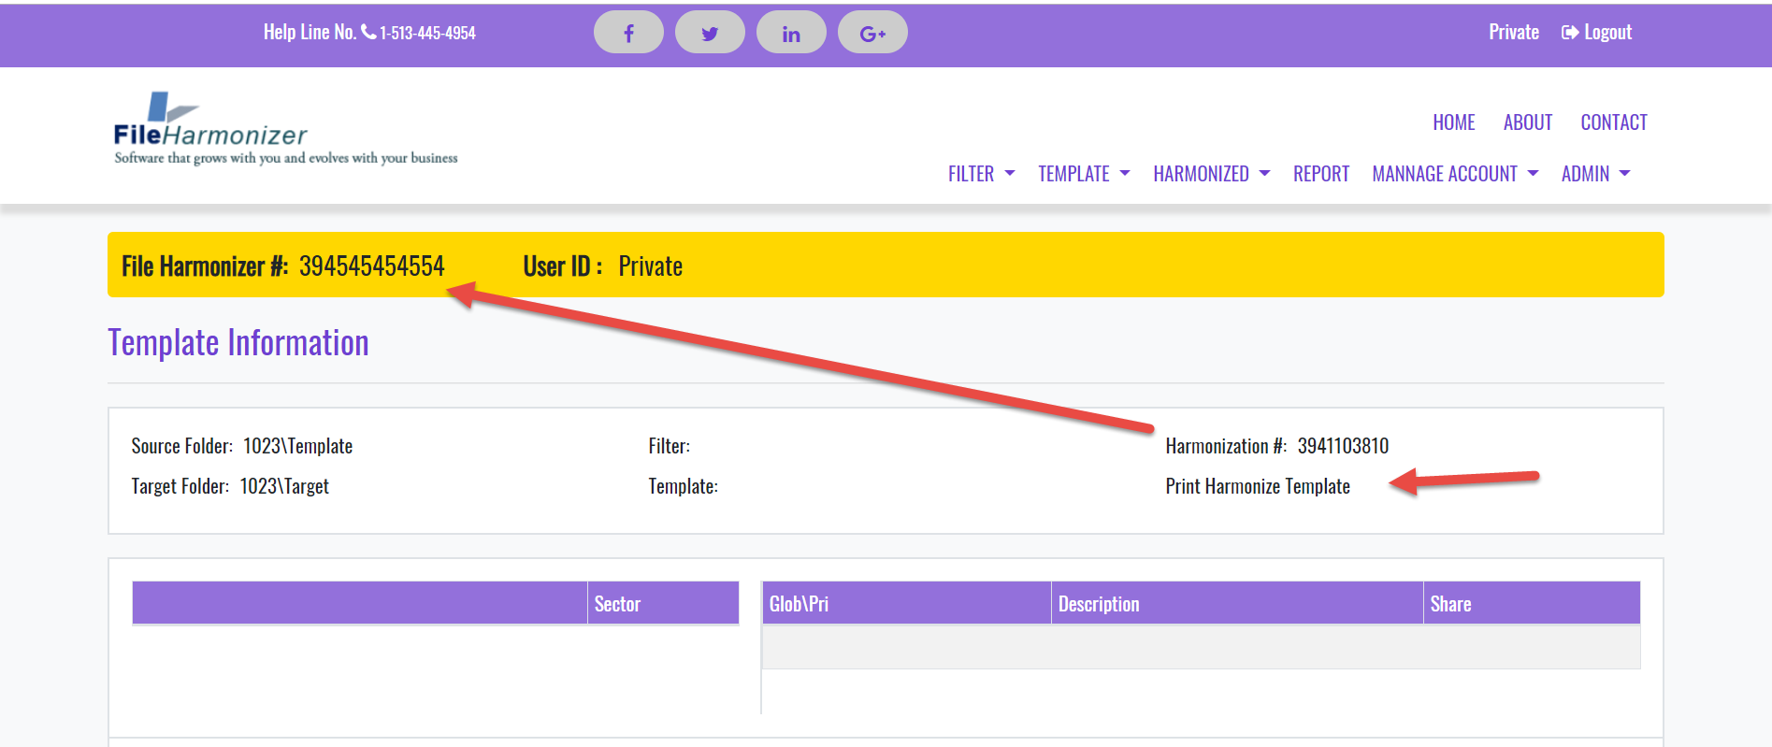

* Inquire about purchase of Microsoft Open Viewer (for .net) **– In Progress**
* GroupDocs.Viewer for .NET <https://code.msdn.microsoft.com/ASPNET-Document-Viewer-e7c2a39f>
* <http://www.rasteredge.com/how-to/csharp-imaging/pdf-html5-on-visual-studio-net/>
* <https://purchase.groupdocs.com/pricing/editor/net>
* Need .NET compatibility API from bank (narrowed CC down to two companies)

     Ecommerce Paypal, **Credit Card**, etc. –

Applying with PaySimple

**OR**

Applying with **PaymentCloud** company (they partner with **Authorize.net** for Gateway services)

Authorize API below:

**Developer.authorize.net (sample code, implementation guide) -** [**https://developer.authorize.net/**](https://developer.authorize.net/)

* User needs the ability to: edit, merge, append the ‘create’ and ‘harmonize’ filters **– in progress**

Excel file be uploaded to Create Filter from

* File “***FH How it works - Overview***“ has been revised and uploaded into Drop Box please find changes in the Archive Worksheet.

Complete **About US** and **Contact US** : review and send attachment – **To be reviewed by Legal, in progress**

**Progress Review 12-31-2018**

**Tentative Project timeline for the Project:**

* Database Design and table creation (**updates and revisions in progress 12/27/2018**) for:
* Initial Tables with table maintenance: Sector, Industry, Category **- Done (90%)**
* Work with the Developer to design user password table with strong Hash Tag algorithm **– one hash is done with (sha1), another may be required (TBD)**
* Initial Tables with Table Maintenance Screen: Address Information, Personal Information, User Password, Business Partner Information, Personal Values to Share, Personal Sectors
* Finalize Database Schema, make sure data normalize is done, optimize Database indexes, etc.
* Website Layout and Flow (**Target Completion week of 12/31/2018**) for:
* Finalize Screen Flow **– In Progress**
* Screens will need to be designed in for both End Users and in-house **FH Website Support team – In Progress**
* Screens: **Partners**, Harmonization **– In Progress**
* Introduce functionality for drag-and-drop, double-clicking, etc **– Open for Future**
* Screens: Documentation, add other Desired Screens i.e. **About, Contact,** Pricing, Products, etc **– Open (some are done)**
* Introduce functionality for drag-and-drop, double-clicking, etc
* Screens: finalize Documentation, add necessary sub-screens per Database and Developer requirements
* Development & Unit Testing (**Target Completion week of 1/5/2019**)
* Develop Function Module\Method: to use a Filter to Harmonize all files in a Folder **– in Progress (90%)**
* Work with Database Designer and Web Designer to incorporate fields from the Harmonize Function Module\Method (Filter all files in a Folder) **– need FH Testing**
* Unit Test Function Module\Method: create Filter and Template from Source File **– In Progress**
* Unit Test Function Module\Method: use Filter to Harmonize Files in Folder **– In Progress**
* Work with Database Designer and Web Designer to trap and code for unforeseen errors
* Add code to ensure data validation
* Test the development for Performance for high volume of files in a folder and multiple file types
* Start 2nd round of Integration Testing for base functionality (**Target Start Date week of 1/5/2018**)

**Daily Deliverables 1-3-2019**

1. Create template page : "Remove print button text" **-- Completed**

2. Manage filter show duplicate data after "Rename comment" **-- In progress**

3. Change the text: - Maintain Template/Maintain Filter **-- Completed**

4. Removed from menu item harmonized with "harmonize" **-- Completed**

5. "User not maintain" change text from "Manage user" page. **-- Completed**

6. Manage user change with "maintain user" top header and menu item **-- Completed**

7. Put toggle for active and de-active user. **-- Completed**

8. Change Team User Expire date on click button in manage page. **-- Completed**

9. Admin user details:

User ID: Admin

Password: password

You can test admin section: -

- Add standard tag

- Add Country

- Add Sector

- Add Industry

- Add Category

---Please do not delete old data, just change its text.

--- You can play with new data or unused record which is garbage

**Please find solution to download any file in client specific folder path using JQuery.**

**Change default download folder path using JQuery for Chrom/IE/Firefox/Opera/Safari**

Changes/New development after the daily meeting as discussed with client.

1. Look into Standards tag table and get UTAGID behalf of Tag -- **Priority 2**

2. Create functionality for Excel and PowerPoint as Search and replace -- **Priority 1**

​3. Screen flow according to Standard Menu name -- **Priority 3**

**New Screen layout:-**

**Notes:**

**Upcoming Holiday(s):**

* TBD

**Yesterday Issues\Take Away\next steps:**

* Website- Collect and provide website wireframe content **– Joe to look into**: **- In Progress**
* Images **– More to be delivered upon request**
* Structure layout – wireframe (create filter&template)
* Advertiser (hide for now)
* **Joe need .Net compatibility API from bank**

Ecommerce Paypal, Credit Card, etc. – Joe (866 280 – 3751 x3 to add payment processing)

* Implement the functionality based on UserId/BPId **- In Progress, on track to being completed?**

**Database**

* Create table with 3 user types (Roles): end user, admin, developer\support (Default End-user upon, sign-in) **– In unit testing**
* Details:-   Create Database locally with name **Need to know how to maintain (add\update) the tables**

**Development**

* Target 11/9: Have alignment with Database and Web designers on process flow and user-interaction flow – **In Progress On track for today 11/14**

**Website**

* Target 11/9: Screens will need to be designed in for both End Users and in-house FH Website Support team **– In Progress same sign-in for all user (user role will manipulate the screens)**
* **Joe to provide** high resolution image for banner and content for static page like as : -**in progress**

-Home Page **- See image in DropBox**

-About US – **Joe to provide**

-Contact US - **Joe to provide**

**Potential Future Functionality**

* Block users from signing into the system (with a modifiable message)- system not available for next ???? minutes/hours
* Maintain messages for users upon – signing in, notifying them of future system (unavailability)
* Link\Import SharePoint views into File Harmonizer
* Search Replace .PDF
* Sort Filter Replacement values (character count) from high to low
* Language Translation
* Create File Harmonizer App
* Bar Code to scan FH # (on App)
* Power Point - migrate into new template format
* Archive a Filter\Solution\Project (to ZipFile)
* Restore Archived Filter\Solution\Project (from ZipFile)
* Reporting (Progress and Errors)
* Progress Indicator (during File Harmonization process)
* Simultaneous File Harmonization Processing
* User will need options to choose Sector, Industry or category). Since the SECID can be gather from all three, the rest of you coding\tables will not need to be changed. We will continue to show Sector in Template Sector. e.g. if industry "6231 - Nursing Care Facilities (Skilled Nursing Facilities)" is chosen, then Template Sector will still be "Health Care and Social Assistance" No change required. However, INDID in 'Create Filter' and 'Harmonize Filter' will be updated with industry # 6231.
* Error Handling:

BP User ID Expired

Invalid User ID for BP

Account Archived

* Log File Processing
* User should be able to review BP# Template prefilled with their own information, to see if anything is omitted
* During create filter should be able to introduce a custom word and the custom Tag into a source file before saving as template – as tag placement (to allow Tags to be added to open question i.e. custom word ‘**fhname’** tags ‘F<FName>H’ ‘F<SName>H)’ custom word ‘**fhfngSize**’ custom tag ‘**F<myFingerSize>H**’